Molybdenum Disulfide

Section 1: Overview[1,2]
- Molybdenum disulfide (MoS₂) is a semiconducting transition metal dichalcogenide with a layered structure.[1]
- In monolayer form, it has a direct electronic bandgap of 1.8 eV and is of wide interest for electronic, optical, and electrochemical applications.[1,2]
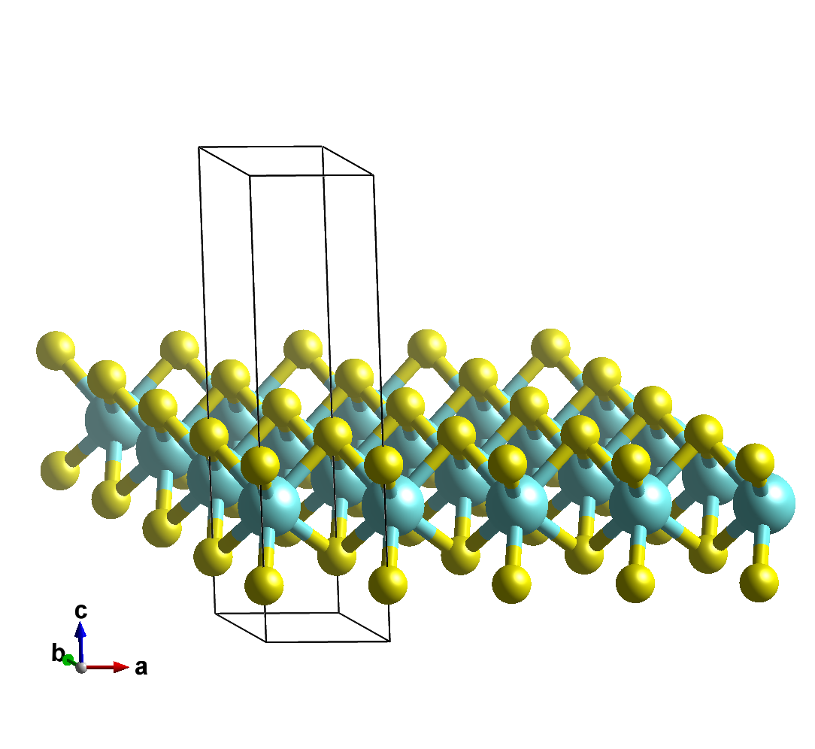
Figure 1. Atomic model of monolayer MoS₂.[1] Mo atoms are cyan, S atoms are yellow. The unit cell is shown.

Section 2: Crystal Structure[1]
- Space group:
- Lattice constants:
- Wyckoff positions and atomic coordinates
- Any other relevant structural information
- You could include a picture of the space group from the international tables.

Section 3: Synthesis and Processing[2]
- Information on synthesis and/or processing of your material.
- Is it mined? Where? What next?
- Is it synthesized? How? From what? What next?
- How does processing affect the structure shown in Section 1?
- You could include a figure showing the primary synthesis or processing steps.

Section 4: Properties
- What are the interesting properties of your material (electrical, optical, thermal, etc)?[2]
- How do the properties relate to the structure shown in Section 1?
- How do the properties relate to the synthesis and processing described in Section 2?[3]
- You could show a figure of the properties.

Section 5: Computational Results
- What parameters were used in SIESTA?
- Include a figure showing the band structure from your SIESTA calculation. Be sure to label the Fermi energy. It would also be good to label the band gap, if any.
- Is the material a conductor, semiconductor, or insulator?

References
- List the references used for the information provided above.
- Format the references as below
- E. Graugnard, et al., “DNA-Controlled Excitonic Switches,” Nano Lett. 12, 2117 (2012).

